**Course: Operating System**

**Section:AM**

**Lab Task: Lab 0**



**ID: SP19-BSCS-0021**

**Name:Taimoor Manzoor**

**Section:AM**

**Task no 1**

**Command : Pwd**

**Output:**



**It shows the current directory where we are working.**

**Task no 2**

**Command : date**

**Output:**



**this command show the current time and date of the system**

**Task no 3**

**Command : date -u**

**Output:**



**it show the universal coordinated time and date**

**Task no 4**

**Command : date --date=”12/02/2014”**

**Output:**



**this command is terminated**

**Task no 5**

**Command : date --s “12 MAR 2021”**

**Output:**



**IT IS NOT SET THE DATE OF THE SYSTEM**

**Task no 6**

**Command : date +%d**

**Output:**



**It shows the current date.**

**Task no 7**

**Command : date +%m**

**Output:**



**It shows the current month.**

**Task no 8**

**Command : date +%y**

**Output:**



**It shows the year of the system.**

**Task no 9**

**Command : date +%D**

**Output:**



**it shows the full date of the system**

**Task no 10**

**Command : date +%H**

**Output:**



**it shows the which hour are running in a day**

**Task no 11**

**Command : date +%M**

**Output:**



**it shows the which minute are running in a hour**

**Task no 12**

**Command : date +%S**

**Output:**



**it shows the which second are running in a minute**

**Task no 13**

**Command : date +%T**

**Output:**



**It shows the current hour ,minute and second of a day.**

**Task no 14**

**Command : date +%a**

**Output:**



**it show the abbreviated weekday name**

**Task no 15**

**Command : date +%A**

**Output:**



**it show the full weekday name**

**Task no 16**

**Command : mkdir Abdulrehman**

**Output:**



**we can create the folder**

**Task no 17**

**Command : mkdir -p Abdulrehman/MySubDir**

**Output:**



**we can create new folder by specify the location or directory**

**Task no 18**

**Command : ls**

**Output:**

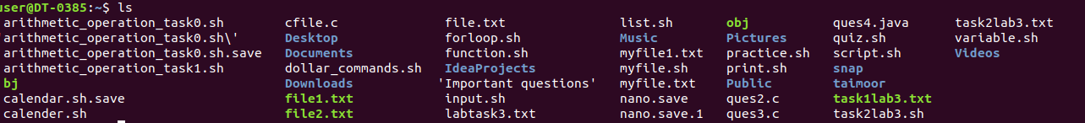

**list the content of current directory**

**Task no 19**

**Command : ls Abdulrehman**

**Output:**



**It shows the inside material of the folder.**

**Task no 20**

**Command : ls -a**

**Output:**

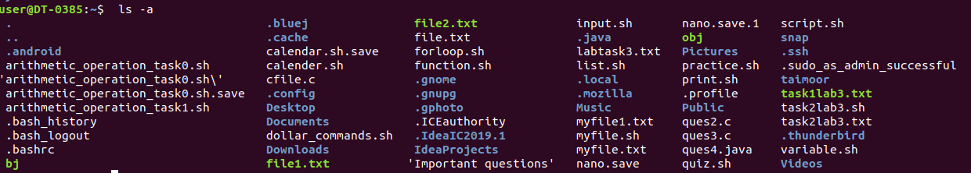

**it lists all files,including hidden objects.**

**Task no 21**

**Command : ls -l**

**Output:**

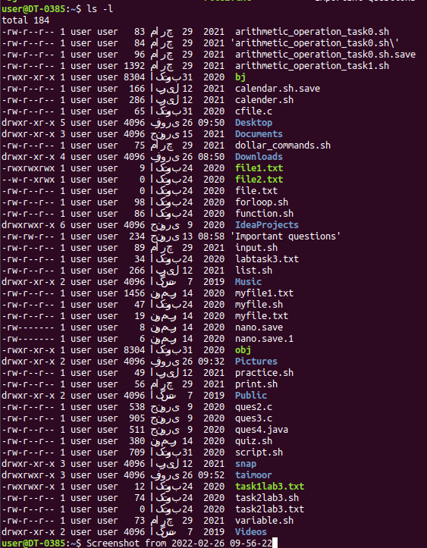

**it is list long content in detail**

**Task no 22**

**Command : ls -h**

**Output:**



**it is list content of human readable format**

**Task no 23**

**Command : cd**

**Output:**



**it change the directory to specified directory**

**Task no 24**

**Command : cd ..**

**Output:**



**it return the parent directory**

**Task no 25**

**Command : rmdir -p Abdulrehman/MySubDir**

**Output:**



**delete the directory hierarchy .**

**Task no 26**

**Command : rmdir -p Abdulrehman**

**Output:**



**delete the folder.**